Mercantilism: How the Mother Country Hits the Mother Load
During the Age of Exploration, European countries such as Spain, France, England and the Netherlands all attempted to increase their world status by gaining power. But how does a nation climb the ladder to world domination? During the Ages of Exploration and Colonization, the answer was simple: gold. The concept that “money equals power” is not a new one. Even in today’s society, it is the rich who are often powerful and famous. So how does this same principle apply to rivaling countries during the 1600 and 1700’s?
Throughout history and the world, different economic systems have existed, which serve as guidelines for how people and nations trade with one another. You may be familiar with the Barter System, which was an economic system where people simply traded goods for other goods. This would have been used before the establishment currencies, or money. When people bartered, they would trade, for example, two baskets of corn for one deerskin robe. In this example, money does not yet factor into the equation, and trade was happening on a local level. However, as times changed and precious metals, like gold and silver, became valuable, nations began using them to trade. Money, specifically gold, is a key component of the Mercantilist System. Mercantilism is the idea that a country’s worth is dependent on the amount of gold that they have acquired. The more money that a country had, the more powerful they became. This meant that countries also had to maintain a favorable balance of trade, meaning they should not import more than they export.
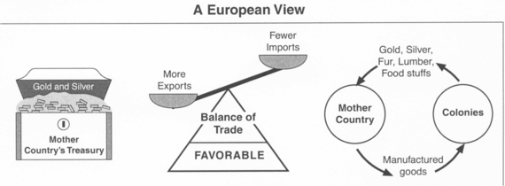
European countries snatched up and held onto as much gold as possible. Most European countries did not have a great deal of gold naturally, so they would send out explorers during the Age of Exploration to find new lands that were able to produce gold and silver through mining. The Spanish Conquistadors were highly successful in bringing gold from Central and South America. They conquered the natives, stole their gold, and enslaved them, forcing them to continue mining the rich land for more precious metals. Other European countries sought to do the same through conquering other lands and colonizing, or inhabiting them.
Under Mercantilism, Britain and other European countries used their colonies as a way to gain wealth and power. Triangular Trade began between Britain and its 13 North American Colonies. While the 13 Colonies did not produce gold, it did provide rich soil for farming and proved to be plentiful with raw materials. Britain would then import these raw materials for very low prices, and turn them into manufactured goods that they would sell back to the colonies and other European countries at very high prices. This allowed Britain to gain wealth, increasing their power and status in the world. Eventually, Britain passed the Navigation Acts, which was a law stating the 13 Colonies could only sell and purchase goods from their Mother Country, Britain. This caused problems with colonists, who could not sell their goods at competitive prices, and who had to buy goods from only one supplier – Britain. Mercantilism would eventually cause resentment due to the unfair nature of the system.
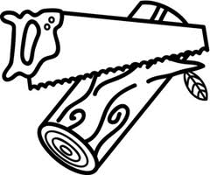
Mercantilism and the Navigation Acts: Step by Step
The 13 Colonies send a load of lumber to Britain. Britain buys the lumber for $10 a load. Even though the colonists feel that a load of lumber is worth at least $20, they must abide by the prices that the Mother Country has determined is acceptable. The Colonies are only allowed to sell certain goods to Britain.
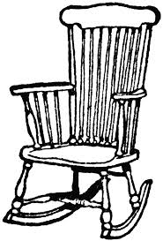
Britain then turns the load of lumber into 10 rocking chairs, which they will sell around the world for $5 each. In the colonies, if someone wants a rocking chair, they HAVE to buy it from Britain and Britain ONLY, even though the French might sell rocking chairs for $4 each. There were even laws forbidding colonists from manufacturing their own products, which forced colonists to buy those products from Britain for high prices.
When Britain sells rocking chairs to the Spanish or the French, they pay using a currency (gold), which adds wealth to Britain, and depletes the wealth of either Spain or France. This helps Britain to rise in wealth and power. When colonists buy rocking chairs, they pay elevated prices set by Britain.
The system of Mercantilism is designed specifically to benefit the Mother Country by exploiting the Colony. The use of trade barriers and regulations assures that the Mother Country will always have paying customers and a readily available source of cheap raw materials to satisfy their manufacturing needs. For the Colonies, the system of Mercantilism forces the hand of colonists to “sell low” and “buy high”, which is not a successful economic plan.

